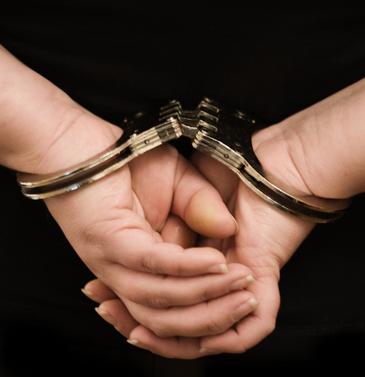

What do I need to know?

Meanings of crime [ ]
Measuring crime [ ]
Biological and psychological explanations [ ]
Sociological explanations for crime [ ]
Labelling [ ]
Types of crime [ ]
Formal and informal social control [ ]
Age, gender and ethnicity and crime [ ]
Dealing with offenders [ ]
The police [ ]
The media and crime [ ]



Meaning of crime and deviance
Using pages 256-257 in the Blundell textbooks, answer the activities below....
Crime means _______________________________________________________________________
__________________________________________________________________________________
Deviance means ____________________________________________________________________
_________________________________________________________________________________
Deviance is relative because the act can have different meaning to different people. Factors which can affect an act being views as deviance include...
- The place
- The time
- The person
- The country
- History.
Now create a Mnemonic for the letters in bold to help remember these factors...
____________________________________________________________________

Now, in the 2 bubbles below write 4 examples of crime and 4 examples of deviance....

Deviance
Crime

Measuring crime
Using pages 258-259 in the Blundell textbooks, write what the following types of statistics are....
Home office statistics ________________________________________________________________
__________________________________________________________________________________
Victim surveys ______________________________________________________________________
__________________________________________________________________________________
Self-report studies __________________________________________________________________
_________________________________________________________________________________
Now, find the following advantages and disadvantages of using statistics to measure crime in the wordsearch below, and then write next to each whether it is an advantage or disadvantage.

L K U D H Z E E I R E H W C R S Z W S G P R
X E X T B B R Q T R E B Q K F I U O H S R B
Q O R Y Q Y U V Z A M L P G R N C J S Y V G
R O Y N P B G Y D S R U I Q R I W I D Z R Y
M P X L B D I Z H E X T G A A X K C Q J N Q
K Y H A Q N F A R D R U R L B E Q I L I C S
I K N K E F K T F T Q D L O E L Q Y N G A K
N S I D A D R H R P B Y V H P Z E M G L O S
V S N C F L A C P D C I P O T E O W W J C C
A U E M A A D R N O N O Y R M C R I P P G N
L J U R Q G N I N E G L D D F F D W F Q Y C
I F J Z L B F S M A S L A N B H H N O V S Z
D S R E W O T P R T Q Z T Z V Y K P J L P U
Q Z O Q T R B D J Z C Z E T J U Z R X P R O
O V R Y U E V I T A T N E S E R P E R T R O
Q V S C Y S N K P S V P S I D I Y T V Y J T
B A T K Q P G F H M I D N Y O S B Z U G E T
E E J B F I X Z D T Z W O N A U Q Z W B S F
D Y U W D H N S W L E R H R K H S S V Y E E
X Q T X T F Y A M R Q Q P Y I J P R B N D J
L I A U D N V R E Y L U P T O D A T E L B R
E P P H X X N J M C Q G L U E A A O K V I M

DARKFIGURE _________________
EASYTOFIND _________________
INVALID _____________________
LOWREPORTRATE _____________
RELIABLE ____________________
REPRESENTATIVE ____________________
SOCIALLYCONSTRUCTED ___________________
UPTODATE _____________________________
Biological and psychological factors

Look at the image of the typical criminal according to Lombroso and Eysenck and write three biological characteristics and three psychological characteristics.
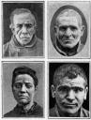
Psychological characteristics
Biological characteristics

Sociological explanations for crime
Use pages 262-263 in the Blundell textbooks, design a mindmap which depicts the main reasons sociologists have argued causes crime.

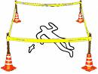

Labelling
Use pages 264-265 in the Blundell books to help answer the following activities.
Labelling is ________________________________________________________________________
__________________________________________________________________________________
Labels are negotiable because _________________________________________________________
__________________________________________________________________________________
A master status is ___________________________________________________________________
__________________________________________________________________________________
A self-fulfilling prophecy is ____________________________________________________________
__________________________________________________________________________________
For the following example, draw a cartoon help explain how a person who becomes labelled reacts to it.

Having accepted the label the person gets treated like it becoming their master status.

The person negotiates the label and accepts it.

Person gets labelled a criminal

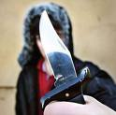

Types of crimes.
Below is a puzzle which when unscrambled will tell you about the different types of crime evident in our society.
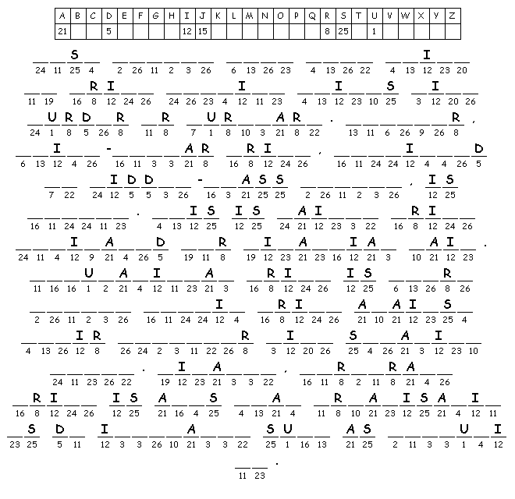
Now, in the space below add in three example of white-collar crime.

Formal and informal social control
Use pages 268-269 in the Blundell books to help answer the activities below…..
Social control means _________________________________________________________________
__________________________________________________________________________________
Formal social control means ___________________________________________________________
__________________________________________________________________________________
Informal social control means _________________________________________________________
__________________________________________________________________________________
In the table below add four types of informal and formal control.
Informal social control | Formal social control

Age and crime
According to statistics people aged 16-24 commit the highest amount of crime in our society. Using pages 276-277 in the Blundell textbooks, design a mind map which shows the reasons sociologist have offered for why this is.

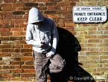

Gender and crime
According to statistics males commit the highest amount of crime in our society. Using pages 274-275 in the Blundell textbooks, design a mind map which shows the reasons sociologist have offered for why this is.



Ethnicity and crime
According to statistics Afro-Caribbean’s commit proportionally the highest amount of crime in our society. Using pages 278-279 in the Blundell textbooks, design a mind map which shows the reasons sociologist have offered for why this is.

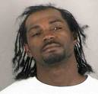

Dealing with offenders
Using pages 272-273 in the Blundell books, unscramble the following sentences given to someone guilty of an offence.

barpotion ___________________________
enif ___________________________
Pinsor ___________________________
citymomnu icerevs ___________________________
baleoust cedarsigh ____________________________
loandiction racedsigh ____________________________

In the table below, write four positives and four negatives with prisons.

Positives | Negatives

The police
Using pages 270-271 in the Blundell books write the three roles police officers play in society.

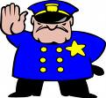
Media and crime
The media play a big part in the portrayal of crime. Through the deviancy amplification spiral, events can be sparked into a moral panic. A famous example of this is the study by Stanley Cohen entitled Mods and Rockers. Here groups of teenagers were blamed for most of society’s problems at the time, leading to the media depicting them as a dangerous group needing sorting out! But, in reality they were not as dangerous as the media led us to believe.
Past exam questions
(b) Explain briefly one way in which individuals try to persuade others to conform to their
norms. (2 marks)

(c) Identify and explain one way in which governments have tried to reduce crime and antisocial behaviour among young people over recent years. (3 marks)

(d) To what extent would sociologists find official crime figures helpful in providing an
accurate picture of how much crime there is? (9 marks)

(b) Explain briefly what sociologists mean by informal social control. (2 marks)

(c) Identify and explain one reason why most convicted criminals are male. (3 marks)

(d) To what extent would sociologists agree that labelling teenagers as deviant leads to an increase in youth crime? (9 marks)

