AQA GCSE

2023 – 2024
Perspectives
Research Methods
Family
Education
Crime
Social Stratification

Exam Board: AQA 8192

Name ……………………………………………………………………

Contents

Overview of Exam Papers 3
How to Answer the GCSE Questions 4
Suggested Revision Tasks 5
Add your own list of things you want to do for sociology revision here: 5
Overview of Sociological Theories 6
Research Methods Knowledge Organiser 7
Research Methods Glossary 9
Family Glossary 10
Education Glossary 11
Crime and Deviance Glossary 12
Social Stratification Glossary 13
Family Key Studies 14
Education Key Studies 15
Crime Key Studies 16
Social Stratification Key Studies 17
Family - Items Exam Questions 18
Family - Practice 3 Markers 22
Family - Practice 4 Markers 23
Family - Practice 12 Markers 25
Education - Items Exam Questions 30
Education - Practice 3 Markers 34
Education - Practice 4 Markers 35
Education - Practice 12 Markers 37
Crime and Deviance - Items Exam Questions 42
Crime and Deviance - Practice 3 Markers 46
Crime and Deviance - Practice 4 Markers 47
Crime and Deviance - Practice 12 Markers 49
Social Stratification - Items Exam Questions 54
Social Stratification - Practice 3 Markers 58
Social Stratification - Practice 4 Markers 59
Social Stratification - Practice 12 Markers 61
‘Identify and Explain’ 4 Markers – Sentence Starters for 4 Markers 66
‘Discuss how far sociologists agree…’ – Sentence Starters for 12 Markers 67
Model PEELE Paragraphs for 12 Markers (Education) 68
12 Mark Sociology Essay Question Planning Sheet 69
12 Mark Evaluative Essay Mark Scheme 70

Overview of Exam Papers
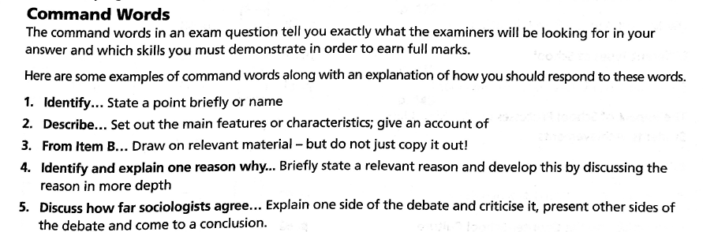
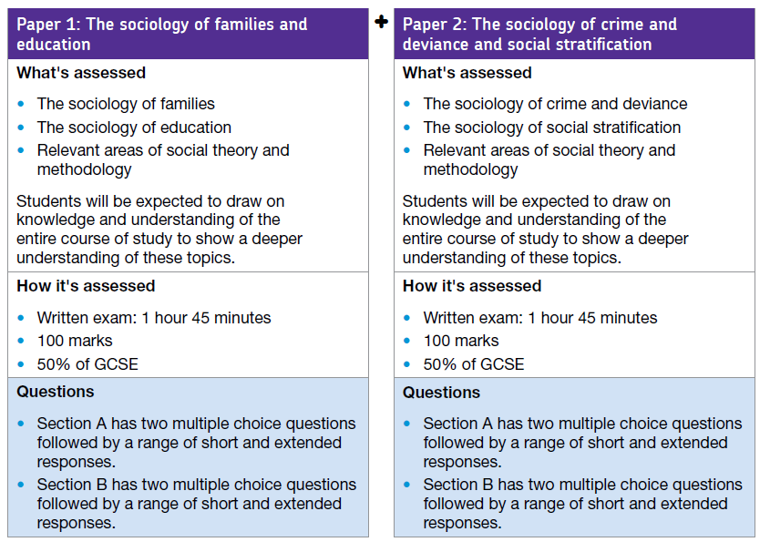

How to Answer the GCSE Questions

Type of Question | Advice |  | Marks
Key Term Multiple choice | Which term…Tick only one of the four word options available  Make sure you read the description carefully and double check your answer. |  | 1
Identify / Describe | [Identify and] describe – Show good knowledge and understanding of relevant sociological theories, concepts, evidence and methods. Write three clear and distinct sentences. Can either do three different ideas or write a mini PEE paragraph if it asks you to identify and describe just ONE thing. |  | 3
Examine (Item) | Examine one [strength/weakness] of research method applied to the context of the item (source) – identify a relevant point and briefly say why it is a strength or weakness by accurately linking it to one of the following concepts: validity, representativeness, generalisability, reliability. |  | 2
Identify and Explain/Describe:  - Factor  - [Dis]advantage of RM  - Named theory/study (linked to Item)  - Sociological concept / issue / how you would research | Write one paragraph in which you name and identify the point clearly and specifically [1 mark] and then give a detailed and well developed explanation/description of relevant sociological theories, concepts, evidence and methods relevant to the question. Make sure you apply this information by linking it to the context of the question [3 marks] |  | 4
Discuss How Far Sociologists Would Agree - Evaluative Essay Question | Discuss how far sociologists would agree that [argument]  Overall Structure:  - 1 PEELE paragraph for the statement  - 1 PEELE paragraph with an alternative perspective on the statement  - Brief Conclusion to link back to question (choose the side which puts forward the best idea and give a brief reason for your choice) | Point (this is the main idea you want to make in support of the question – you could begin by referring to a theory here)  Evidence (how can you back up your point? Use contemporary examples, studies, theories and named sociologists)  Explanation (you need to say how that evidence supports the first point you made: link it to the context of question)  Link (say how the material in this paragraph links to the essay question)  Evaluation (present a direct criticism of this viewpoint). | 12

In each exam paper there are 22 exam questions (11 questions in each section)

Each section (family/education/crime and deviance/social stratification) follows this same structure:
- 2x multiple choice
- 2x 3 marker 'identify/describe’
- 1x 2 marker ‘examine’ research
- 4x 4 marker ‘identify and explain/describe’
- 2x 12 marker ‘discuss how far sociologists would agree…’ evaluative essay questions.
Each section is out of 50 and each overall paper is out of 100.

Suggested Revision Tasks

- Regularly test yourself on the key vocabulary in each of the glossaries - practice writing the words into sentences. Highlight the words you find the most difficult to remember and start with these. Turn these into revision cards
- Make mind maps on different research methods, with 2 or 3 key advantages and disadvantages
- Read and highlight the information on the key studies you need to know.
- Create a summary mind map or revision cards trying to reduce the information into a few bullet points with key phrases and sociological concepts. Use pictures / images if this is helpful to you.
- Create your own multiple choice quiz on all of the key thinkers and material you need to know from the advanced information grids. Create an answer sheet separately (so someone else can test you).
- Get someone to test you on your multiple choice quiz. Repeat this process regularly.
- The following pages contain all of the past exam questions, separated by topic and then into Items (sources) questions, followed by 3,4 and 12 marker questions. Choose the ones you find hardest and practice those first into this booklet. Remember to aim for 1 minute per mark time wise.
- Highlight any 12 marker essay questions which you would find challenging and create essay plans for them using your exercise book and revision guide. Revise your plan (using the look, cover, say, check method or by telling someone your plan out loud).
- Practice writing the essays in timed conditions (without your plan). There are sentence starters in this booklet, as well as a mark scheme so you can self-assess your work.

Add your own list of things you want to do for sociology revision here: | Tick when done

Overview of Sociological Theories

Marxism  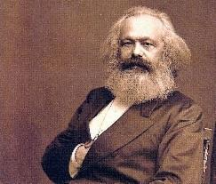 | A theory developed by Marx and Engels that describes society as being in a state of conflict between the ruling class (bourgeoisie) and the workers (proletariat) who work for them. The whole of society is organised in ways that benefit the ruling class and allow them to exploit the workers. Marxist sociologists think that the structure of society causes inequality and are interested in exposing and studying these systems of exploitation.
Functionalism  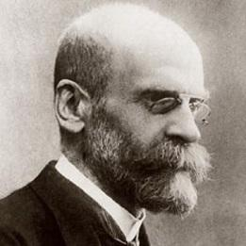 | A theory developed by Durkheim that describes society as being in a state of balance or agreement (consensus). Each aspect of society (education, family, work etc) serves a function that helps maintain society as a whole but also acts as a ‘social glue’ that keeps people together as a group. Without this social glue, people feel they are disconnected from wider society and experience anomie (a breakdown of norms). Functionalist sociologists are interested in studying the ways in which different aspects of society function to maintain consensus and prevent anomie.
Feminism   | A theory developed by many different people, mostly women, that describes society as an unequal relationship between men and women that keeps them in a state of conflict. The whole of society is organised in ways that keep power in the hands of men (even though not all men may benefit from this power, or it may even be harmful to men). This system is called the patriarchy. Feminist sociologists are interested in exposing and studying this system of power and exploitation and showing how it affects women.
Interactionism   | A micro theory developed by a number of sociologists that focuses not on looking at society as a whole but instead looks at how people interpret the world around them and interact with each other. Our lives are made up of social interactions that communicate what we mean to other people and try to make sense of what they are meaning. Interactionist sociologists are interested in studying how people communicate with and interact with each other to share ideas of culture, norms and values.
Weberianism  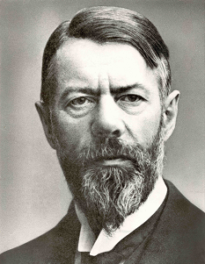 | A theory developed by Weber that describes society as being in a state of conflict between those with status, wealth and power and those without. Weberian sociologists are interested in studying where power, wealth and status exists in society and how they are used by people.

Research Methods Knowledge Organiser

Stages of carrying out research |  | Ethical Issues |  | Sampling
- Generate a testable hypothesis: a statement/question that can be investigated.  - Design your study: choosing the correct research methods and sampling strategy  - Conduct a pilot study (practice research investigation): designed to see if the main study is feasible.  - Apply your revised research method/s by collecting primary/secondary data  - Analyse data to see if it is reliable, to make it into useful information, and to represent it using graphs/chart to investigate trends, patterns and correlations.  - Draw reasoned conclusions that are presented in a clear and useful manner. |  | - Consent - Participants must give their consent (permission) to take part.  - Informed consent - Participants must be made aware of any dangers/risks, and be made aware of their right to leave the research at any stage (right to withdraw).  - Safety - Researchers have a duty to protect their participants (and research team) and not to expose them to undue risks. This includes causing emotional distress.  - Sensitivity - Researchers should be sensitive when dealing with vulnerable groups.  - Debriefing - At the end of the experiment, participants must be debriefed: given an explanation of the nature of research and how the experiment works.  - Confidentiality/Anonymity - Researchers must respect the confidentiality of their participants. This also includes storing all relevant data securely.  - Not misrepresenting data - Researchers must have integrity: they must be honest and not tamper with data. |  | - Random sampling – This is when everyone has an equal chance of being selected.  - Systematic sampling – Choosing randomly from a list. E.g. every 5th, 10th or 20th person on a register or from a list.  - Stratified sampling – to make the sample as representative as possible, the sample frame will be divided into a number of smaller groups, such as social class, age, gender, ethnicity etc. Individuals are then drawn at random from these groups.  - Snowball sampling – This is when you ask your participants to recommend other participants  - Opportunity sampling – Where the most convenient or suitable persons are picked.  - Cluster sampling – This is when the researcher divides the population into separate groups, called clusters. A random sample of clusters is selected from the population.  - Quota sampling – interviews must question an exact quota (number) of people from categories such as females, teenagers, in proportion to the numbers in the wider population.
Different Methods of Research

 | Advantages |  | Disadvantages
Overt Observations | - Can collect detailed and in-depth qualitative data which is likely to be high in validity so it can help you understand what people do and why.  - If non-participant then you are likely to remain apart from your research subjects and so will remain more objective.  - If participant observation is used you will really understand the group under study and see things from their point of view.  - There is no deception involved in the research so nobody feels compromised.  - If structured using grid tally observation and operationalised terms then you can get reliable data. |  | - Overt observations may result in the group under study changing their behaviour due to the observer – the Hawthorne effect.  - Time consuming and likely to be expensive to complete as many observations are longitudinal.  - It can often be difficult to gain access to the groups you wish to observe.  - Often difficult to take notes when observing so many researchers have to rely on their memories later which means much can be forgotten or misconstrued.  - If participant observation is used, many researchers find that they become too involved with the group they are studying and start to lose their objectivity.  - It doesn’t get reliable data (participant observation is unstructured).
Covert observations | - Allows the researcher to see participants in their natural environment – improved ecological validity;  - Prevents people from changing their ‘normal’ behaviour – avoids the Hawthorne Effect.  - Increases validity as people do not know they are being studied.  - If using participant observation, it allows the researcher to act as part of the group under study and to really understand things from their point of view – improved validity.  - May allow research to be conducted upon groups that would not normally allow researchers in i.e. prostitutes, the homeless, criminals, gangs etc. |  | - Covert observations have a number of ethical issues  - Difficult to gain access to the group you wish to study e.g. for a covert participant observation, as groups are often deviant/taboo i.e. drug dealers, gangs etc.  - Not ethical – difficult to morally justify spying on people;  - May put the researcher in danger if the group finds out they are being researched and have not given their consent.  - Danger of the researcher ‘going native’ and losing their objectivity.  - Research conducted covertly is typically small-scale and therefore is unlikely to be representative meaning generalisations cannot be made.  - Taking notes/recording information in a covert research study would be very difficult meaning information could be forgotten/changed and therefore lessen its validity.
Longitudinal study | - Allows a researcher to build up a picture of social life that recognises changes over time.  - Helps to prevent the study from going out of date  - Allows for lots of depth and detail.  - Helps the researcher to build a rapport with the participants which helps to gains more valid data. |  | - Difficult to manage as people’s circumstances are constantly changing  - Time consuming for the researcher - Interviews are quite time intensive as they involve a conversation  - Costly for the researcher  - Researcher may have to cope with participants dropping out of the study or moving away
Interviews | - The researcher gets to speak to the respondents face-to- face so can persuade people to answer thus reducing the problem of non-response.  - Interviews can be conducted by phone, avoiding the expense and possible issues of social desirability/interviewer bias.  - In unstructured and semi-structured interviews, the researcher can probe to really find out what the respondent means, so increasing validity.  - They produce qualitative data that can be used to find out about attitudes and opinions; Interviews are good for gathering in-depth and detailed information.  - Questions can be rephrased and explained if respondents aren’t sure what they’re being asked; Group interviews allow discussions to take place to really explore feelings and viewpoints.  - Structured interviews allow for respondents' answers to be compared and are a reliable method.  - Interviews involve interaction between the researcher and the respondent encouraging open and honest responses which are likely to be more valid.  - Seeing body language helps you to build rapport/tell if someone is telling the truth.  - High response rate – difficult to say no to a researcher face-to-face. |  | - Can cost a lot to conduct as interviewers have to be trained.  - Sample sizes are often quite small when interviews are used as a research method which may lead to issues with a lack of representativeness and generalisability of data.  - Interviews are conducted in artificial situations therefore you can never be certain that what is said in an interview is actually what the respondent really thinks.  - Interviews are only as successful as the researcher carrying them out, particularly true in an unstructured interview where probing is essential.  - If respondents are not asked the same questions i.e. in unstructured interviews, then comparisons between findings are hard to make.  - There is a risk of interviewer bias which may affect the validity of the data.  - Sometimes respondents may give answers that they feel the interviewer wants to hear, so reducing validity – socially desirable responses.  - Recording errors may reduce the validity of the data collected.  - Respondents can lie e.g. because they don’t want to look bad in front of someone, which reduces validity.
Questionnaires | - Relatively easy and cheap to complete research therefore can target a large sample and gain more data.  - If comprised (made up) of closed questions, is good for gathering quantitative data which can be used to compare the responses of different social groups.  - Relatively quick and easy to complete as a respondent so shouldn’t be any problems in terms of knowing what to do.  - If self-completion can be completed at leisure allowing people time to complete properly and fully.  - If postal can be sent out to a wide geographical sample and so improve representativeness of data gathered  - Often completed in private, so avoids any researcher effects.  - Standardised questions means the reliability of the data gathered should be high. |  | - Often uses closed questions so unlikely to produce detailed, qualitative data therefore not good for finding out why people think/act as they do.  - Closed questions may mean people have to tick an option box closest to what they think rather than what they actually think thus reducing validity of data gathered  - May be rushed or not taken seriously meaning answers may lack validity.  - If self-completion no way of checking the person you intended to complete the questionnaire actually did so  - Problems of non-response may result in a distorted sample and thus less representative data.  - If self-completion no way for respondent to raise any queries about any part of the method meaning that it may not be completed in the way that was intended.  - Any leading questions may bias respondents answers.
Content Analysis | - Cheap to complete research – only really need some media to analyse.  - Can target a sample and gain more data.  - Easy to research - the rapid growth of the internet has made the process even easier with a vast array of media now available online to access and analyse.  - Straightforward to complete research as you really just need to tally up the number of times each category in your grid/chart is shown.  - Reliable method – others can check the findings by using the same grid and applying it to the same sample to see if they get the same results.  - Produces quantitative data which can be turned into statistics so various comparisons can be made to establish any patterns. |  | - The media is often biased so the researcher needs to be aware that results may also be biased.  - Success of the method depends on the quality of the categories - if important points are missed out then these will also be missing from the results which results in an incomplete picture.  - If categories aren't clearly operationalised then there will be a lack of consistency when completing research leading to issues of reliability - especially important if research is being completed by a team as they would all be recording different information in different categories.  - The quantitative data produced will not be detailed or in-depth or explain why the content is as it is, leading some researchers to question its usefulness.  - Results are often based on the judgements and opinions of just one person, which is likely to make any conclusions biased
Official National Statistics | - Many official statistics are freely available to researchers and the general public.  - Easy to access and to navigate by using the ONS website.  - Enable us to make comparisons between social groups and regions, for example the UK National Census.  - Enable us to make historical comparisons over time because they often go back a long way.  - Allow us to spot trends, find correlations and make generalisations.  - Allow the research to remain detached so there is less room for the subjective bias of the researcher to interfere with the research process. |  | - Statistics are free, but they are expensive and time consuming to collect.  - The data which exists and the categories and indicators used might not fit a researcher’s specific research purposes.  - Some Official Statistics lack validity, for example crimes may go unreported and so aren’t counted.  - The way that some social trends are measured changes over time – sometimes making historical comparisons difficult.  - Official statistics may also lack validity because they are collected by the state and massaged to make things look better than they actually are.

Research Methods Glossary

ESSENTIAL VOCABULARY
- Hypothesis | A supposition, hunch or informed guess, usually written as a statement that can be tested and then either supported by the evidence or proved wrong.
- Ethical issues / considerations | Issues such as informed consent and confidentiality that sociologists must consider in order to conduct morally acceptable research.
- Data: Qualitative and Quantitative | Qualitative: information presented as words or quotations.  Quantitative: information presented in numerical form, e.g. as graphs, tables of statistics.
- Research methods: primary & secondary | Primary: information that is generated and collected at first hand by doing research using techniques such as questionnaires, interviews or observation.  Secondary: information that already exists and has previously been generated by or collected by other people. Sources include official statistics, the mass media, autobiographies, and sociological studies.
- Sample | A subgroup of the population selected for study. See knowledge organiser for different sampling methods.
- Questioning: open and closed | Open: a question that allows respondents to put forward their own answers rather than choose a response from several pre-set answers.  Closed: a fixed-choice question that requires the respondent to choose between a number of given answers.
- Observer / Hawthorne Effect | In an observation, individuals or groups of people may modify, change or improve an aspect of their behaviour because they are aware they are being observed. It can affect the validity of the findings.
- Validity | Findings are valid if they truly measure or capture what they are supposed to be studying.
- Reliability | Refers to consistency. Research findings are reliable if, after the research is repeated a second time using the same methods, the same or consistent results are obtained the second time round.
- Representative sample | Reflects the characteristics of its population. It is just like the population but a smaller version of it.
- Generalisability | In designing their study, researchers think about the extent to which their findings can be applied to the larger population of which their sample was a part.
- Sampling frame | A complete list of all members of the population from which a sample is drawn. Examples include membership lists, school registers and a list of postcode addresses.
- Triangulation | Cross checking the findings from a qualitative methods against the findings from quantitative methods. Doing this can improve the validity/generalisability of the research.
- Mixed methods research | The use of different methods within one project to generate both quantitative and qualitative data
- Content analysis | The analysis of documents and images (e.g. media products) by constructing a set of categories, coding sections of the content according to these categories, and then counting the number of times a theme appears.
- Pilot study | A small scale trial that is carried out. This is done prior to the main study. It is carried out in order to test that there are no flaws in the methodology of the main research.
- Case study | A detailed study of a particular institution (such as a school or hospital) or a series of related events (such as the moral panic surrounding teenagers wearing hoodies).
- Confidentiality | An agreement that all information (e.g. gathered from research participants) will only be accessed by those who have the authority and permission to access it.
- Ethnography | The study of people’s culture and practices in everyday settings, usually based on qualitative methods such as participant observation and unstructured interviews.
- Focus group | A type of group interview that focuses on one particular topic. It explores how people interact within the group and how they respond to each other’s views.
- Longitudinal study | A study of the same group of people conducted over a period of time. After the initial survey or interview has taken place, follow-up surveys or interviews are carried out at intervals over a number of years.

Family Glossary

ESSENTIAL VOCABULARY
- Nuclear family | Two generational families containing a heterosexual married or cohabiting couple and their dependent children.
- Extended family | Group of relatives extending beyond the nuclear family but have regular contact.
- Reconstituted family | A blended or stepfamily in which one or both partners have a child/ren from previous relationships living with them.
- Social stigma | Disapproval of a person based on perceived characteristics.
- Patriarchy | Male dominance over women.
- Household | Made up of people who live in one unit.
- Double shift | When a woman takes on a career and the housework. This then can lead to the triple shift, which also involves emotional support.
- Primary socialisation | How a child is taught the norms and values of a society.
- Monogamy | Being married to just one person. This can be serial monogamy, which is when you may divorce and then get remarried.
- Cohabiting | Live together but are not married.
- Dysfunctional families | Conflict, emotional distress and potential abuse.  (This is used to criticise the functionalist perspective as it ignores dysfunctional families in its findings).
DESIRABLE VOCABULARY
- Empty nest | When the children have moved out and no longer live with their parents.
- Canalisation | The way a parent channels their children’s interest into toys/ games and other activities.
- Egalitarian Families | Sharing power between members of the family.
- Principle of stratified diffusion | Social changes start at the top of the social class system and work down (Young and Willmott, 1973).
- Polygamy | Practice of having more than one spouse.
- Polygyny | Men who have 2 or more wives.
- Polyandry | Women who have 2 or more husbands.
- Instrumental role | Men take on this role as the breadwinner (Parsons, 1959).
- Expressive role | Women take on this role as the housewife and mother (Parsons, 1959).
- Joint conjugal roles | No rigid division of household tasks. Shared leisure activities.
- Segregated conjugal roles | Division in domestic labour due to gender. Separate leisure activities.
- Symmetrical family | Spouses perform different tasks but both contribute to the home.

Education Glossary

ESSENTIAL VOCABULARY
- Formal curriculum | The timetabled subjects taught in schools, such as English, Maths, Religious Studies and Spanish. This is called direct learning and refers to the formal things that you learn (for example in a GCSE course).
- Hidden curriculum | Things learned indirectly in school that are not formally taught, such as valuing punctuality, or conformity and obedience. Occurs through things like assemblies, tutor periods, the attitudes and behaviours of staff in school.
- Labelling | The process of attaching a label (a sticky tag), characteristic or definition to individuals or groups. For example, labelling a middle class student as someone who is clever/bright.
- Self-fulfilling prophecy | This occurs when a person who has been labelled comes to fit the image people have of them; i.e. the prediction becomes true.
- Meritocracy | A system in which individuals’ achievements are based on their own talents and efforts rather than their social origins and backgrounds. Functionalists would agree with this.
- Material deprivation | Refers to the inability of individuals or households to afford the goods and activities that are typical in a society at a given point in time.
- Teacher expectations | Assumptions that teachers make about students’ future academic achievements based on their knowledge of students’ current performance.
- Streaming | Dividing students into different groups or bands based on a general assessment of their ability rather than their performance in a particular subject.
- League tables | League tables measure school performance data. This is statistical information showing how well pupils in England have done in public examinations taken at key points during their school careers. They are available for all members of the public to see.
- Marketisation | An attempt to improve education standards and opportunities by making schools and colleges compete for students in an ‘education market’.
DESIRABLE VOCABULARY
- Home schooling / tuition | Teaching children at home rather than at school, usually by parents or private tutors.
- De-schooling | The idea that the education system as it is currently organised should be abolished (stopped/eliminated).
- Gendered curriculum | A curriculum in which some subjects (including high status subjects such as maths and science) are associated with masculinity) and others (such as languages and humanities) are associated with femininity.
- Ethnocentric curriculum | The curriculum is seen as judging things in a biased way from the point of view of one culture. For example, the National Curriculum may value white, Western literature, art, history etc.
- Anti-school subculture | A school-based group of students who resist the school, its teachers and their authority and openly challenge the school rules.
- Counter-school culture | A group within a school that rejects the values and norms of the school and replaces them with anti-school values and norms. Willis demonstrated this in his study of working-class lads in his study called ‘Learning to Labour’ (1977).
- Correspondence Principle | Bowles and Gintis’ (Marixsts) term used to describe the way that education and work connect or fit together (correspond) in capitalist society.
- Competition | A struggle or contest between individuals or groups to obtain (gain) something desirable (such as qualifications, school places, status, power or wealth) that is in limited supply.
- Cultural capital | Bourdieu’s idea that the knowledge, attitudes and values that the middle class provide for their children gives them an advantage in the education system.
- Cultural deprivation | A theory which suggests that some working class and minority ethnic students lack the ‘correct’ values, behaviours and attitudes from socialisation to succeed in education.

Crime and Deviance Glossary

ESSENTIAL VOCABULARY
- Crime | Any form of behaviour that breaks the law
- Custodial sentences | Punishment where offenders will be sentenced to go to prison or Young offenders institute
- Crime rate | A measure of the level of criminal activity in a society based on crimes recorded by the police
- Dark figure of crime | The unknown amount of criminal activity that is not reported or recorded to the police
- Deviance | Any form of behaviour that does not conform to the norms of a society – this can be influenced by time, place, social situation and culture
- Formal agencies of social control | Formal rules and social controls that tell everyone within society what is and is not acceptable e.g. the police, the courts, the government
- Informal agencies of social control | The approval or disapproval of people around us that can influence and control our behaviour e.g. family , friends, peer group, schools, work, religion
- Official crime statistics | Government statistics on crime based on official sources e.g. police records
- Self-report study | A survey that asks respondents to identify crimes they have committed, but for which they have not been caught
- Social construction of crime | What is considered criminal and deviant changes over time or when it takes place, therefore is socially constructed. No act is in itself criminal or deviant- it largely depends on how other member of society see it e.g. homosexuality
- Victim survey | A survey that asks respondents about their experience of crime, regardless of whether or not those crimes have reported
DESIRABLE VOCABULARY
- Anomie | When norms that usually regulate people’s behaviour break down
- Chivalry Thesis | The idea that the criminal justice system treats female offenders (especially those who conform to stereotypes) more leniently than male offenders
- Collective conscience | The shared beliefs that bind communities together and regulate individual behaviour
- Deviant career | Deviant behaviour that develops over time due to labels. e.g. labelled a troublemaker at school and then goes onto commit crime later in life
- Deviancy amplification | The exaggeration of a particular social issue as a consequence of media coverage, e.g. anti-social behaviour by groups of young people
- Edgework | Behaviour at the edge of what is normally allowed for accepted; risky or radical behaviour, e.g. stealing and racing a car
- Hate crime | Crime based on prejudice towards others because of their race, religion, sexual orientation, disability or because they are transgender
- Probation | Prisoners are allowed to leave prison and enter the wider community under supervision, provided they follow certain conditions set by the court
- Status frustration | A sense of frustration arising in individuals or groups because they are denied status in society
- Violent crime | Recorded as ‘violence against the person’, which covers grievous bodily harm (GBH), assault, kidnap, child abduction, harassment and threats to kill
- White collar crime | Criminal acts committed by people in high status positions, such as accountants, doctors or solicitors, during their work, fraud, tax evasion and ‘fiddling’ expense accounts at work.

Social Stratification Glossary

ESSENTIAL VOCABULARY
- Poverty (2x definitions) | Absolute poverty: is when people have incomes that are insufficient to obtain the minimum needed to survive (i.e. shelter, food, water, clothing)  Relative poverty: is when people cannot afford to meet the general standard of living of most other people in their society
- Status  (2x types) | Achieved: Social positions that are earned on the basis of personal talents or merit.  Ascribed: Social positions that are fixed and birth and unchanging over time, including hereditary title linked to family background (e.g. Princess, Lord)
- Cycle of deprivation | The idea that deprivation and poverty are passed on from parents to their children
- Life chances | An individual’s chances of achieving positive or negative outcomes as they progress through life. Life chances are related to health, education, housing, employment
- Authority and power | Authority: the exercise of power based on consent of agreement  Power: the dominance and control of one individual or group over others
- Embourgeoisement | A hypothesis suggesting that working class families are becoming middle class in their norms and values as their incomes and standard of living improves.
- Poverty trap | People can be trapped in poverty if an increase in income reduces the benefits they are entitled to. For example, an employed person receiving means-tested benefits could be worse off after a wage rise if they now earn too much to qualify for benefits.
- Social mobility (3x types) | Vertical: movement up or down between the layers or strata of society.  Inter-generational: movement up or down between the layers as measured between generations of a family.  Intra-generational: movement of an individual over the course of their life up or down from one occupational classification to another.
- Affluence | Having a lot of money and material possessions
- Social Stratification | The way that society is structured into hierarchical strata (layers) with the most privileged at the top and the least favoured at the bottom. Social class is an example of a social stratification system.
DESIRABLE VOCABULARY
- Bureaucracy | An organisation (such as a government department, e.g. DfE – education), that operates as a hierarchy with a clear set of rules. Bureaucratic authority is based on a set of rules that operate within a bureaucracy.
- Relative income standard of poverty | A measure of poverty based on how much income a household has compared to other households. Households could be put in rank order, and then you can identify 10% of the households with the lowest incomes.
- Class dealignment | Weakening of the links between social class and voting behaviour
- Classless society | A society in which there is no private ownership of property and so no clearly structured social classes.
- Environmental poverty | A way of measuring deprivation in terms of conditions such as inadequate housing, a lack of a garden, inadequate outdoor play facilities and air pollution.
- Functionally important roles | Key positions in society that, for example, provide essential services and ensure society’s survival over time.
- Instrumentalism | An attitude or approach to something (such as paid work) where it is a means to an end (e.g. the wages provide a comfortable lifestyle) rather than an end in itself (e.g. job satisfaction).
- Welfare state | A system in which the state takes responsibility for protecting the health and welfare of its citizens and meeting their social needs. The state does this by providing services (e.g. the NHS) and benefits (e.g. Income Support).
- Pluralism | An approach which argues that a range of views, interests and opinions exists in society and no one group dominates the political process.

Family Key Studies
Sociologist | Perspective | Research Method | Key Findings
Parsons | Functionalist | Secondary sources | Two key functions of the family:  - Primary socialisation – children are taught the shared norms and values of society  - Stabilisation of adult personality – family relieves stress of life, like a ‘warm bath’
Zaretsky | Marxist | Secondary sources | The family serves capitalism through:  - Women’s unpaid labour  - Passing on of advantage in families e.g. inheritance  - Unit of consumption
Delphy and Leonard | Radical feminist | Secondary sources | Family is patriarchal because:  - Women are exploited economically – labour is used by their husbands  - Family is hierarchical – men at the top  - Patriarchal family reflects patriarchal society
Oakley | Feminist | Secondary sources | Analyses the ‘conventional family’ finding:  - Women are expected to do unpaid work  - Idea of the conventional family is powerful  - People expect happiness, but nuclear family can be stressful  - Middle class – more family diversity
Rapoport and Rapoport | NA | Secondary sources | Pioneers in researching family diversity. 5 types:  - Organisational – structure of families  - Cultural – cultural/ religious differences  - Social class – class differences  - Cohort – historical differences  - Life course – differences in life cycle of the family
Willmott and Young | Functionalist | Survey; Face- to- face structures interviews | Found that the family was becoming more symmetrical – similar but not identical roles, equal contribution to household work, and shared decision making and friends. Home-centred. Principle of stratified diffusion: changes in family life start with higher social classes and trickle down

Education Key Studies
Sociologist | Perspective | Research Method | Key Findings
Parsons | Functionalist | Secondary sources | - School is an agent of socialisation, and is the bridge between family and wider society promoting 2 values: achievement and equality of opportunity.  - Education teaches the difference between particularistic (individual) and universalistic values; children have ascribed status in families but in schools everyone is judged by the same standards in schools.  - Role allocation and meritocracy: education matches individuals to their future jobs based on talent. In a meritocracy the most able reach the top jobs.
Durkheim | Functionalist | Secondary sources | - Main function of education is to transmit and teach shared norms and values and build social solidarity.  - This is achieved through lessons such as history which help students see themselves as part of a bigger society.  - Teaches children specialised skills for work
Bowles and Gintis | Marxist | Interviews and secondary sources | - There is a correspondence or similarity between work and school – hierarchy, uniform, tasks are boring etc.  - Education creates an obedient workforce to serve capitalism  - This is done through the way schooling is structured and the hidden curriculum  - Meritocracy is a myth
Willis | Marxist | Case study; Participant observation | - Studied the lads – an anti-school subculture – for two years  - Found they were not obedient but their subculture was similar to WC workplaces
Ball | NA | Case study; participant observation and interviews | - Examined the way a mixed comprehensive school was organised – banding.  - Working class students more likely to be in lower bands  - Teachers had different expectations of different bands – i.e. top band students were encouraged, were viewed as well-behaved and hard working. Lower bands were steered towards more practical subjects and were labelled as low ability.  - Mixed ability classes were introduced which reduced this but labelling still happened
Ball, Bowe and Gewirtz | NA | Interviews and secondary sources | - Parental choice and competition has increased inequalities in education  - Middle class parents have more choice – greater cultural capital and material advantage.  - Schools focus on image and results and compete with one another through results, facilities, etc.
Halsey, Heath and Ridge | NA | Face to face survey | - Examined social class origins and educational destinations of a large survey of 8000 men  - Respondents social class based on father’s occupation and divided into 3 types: service, intermediate, working  - Service class boy 11 times more likely to go to university than working class

Crime Key Studies
Sociologist | Perspective | Research Method | Key Findings
Merton’s (1938) strain theory | Functionalist | Secondary sources | - People’s aspirations and goals are shaped by their culture e.g. American Dream = economic success  - Some people experience a strain between the goals of society and the means of achieving them. This may lead to anomie (normlessness)  - They may seek out an illegitimate route to economic success e.g. crime
Becker’s (1963) interactionist perspective | Interactionist | Secondary sources | - Argues deviance is created by society  - Powerful social groups create deviance by making the rules and applying these to others  - People can develop deviant careers if labelled as deviant  - The deviant label can become a master status (main identity)  - Labelling can lead to the self-fulfilling prophecy
Heidensohn’s (1985) control theory | Feminist | Data from her study of delinquent girls; secondary sources | - Women commit less crime because they are more closely controlled in society  - In a patriarchal society, women have stronger social control placed on them which can reduce opportunities for crime  - At home, women are controlled by domestic responsibilities, at work by fear of damaging reputation and in public by fear of male violence
Carlen’s (1988) class and gender deal | Feminist | Unstructured interviews | - Carlen explains why working-class women commit crime  - She argues they are promised two rewards for conforming- ‘class deal’ (money and material items from working hard) and ‘gender deal’ (happy domestic life with husband and children)  - She found WC women committed crime when these rewards were blocked due to: poverty, living in care, drug addiction.  - They had nothing to lose and everything to gain
Cohen’s (1955) subcultural theory | Functionalist | Secondary sources | - Argues delinquency is carried out by groups not individuals, and that groups often commit non-utilitarian (not motivated by money) crimes  - Working class boys experience status frustration at not succeeding in middle class school  - They join/ form a delinquent subculture with an alternative status hierarchy where they will gain status for deviance

Social Stratification Key Studies
Sociologist | Perspective | Research Method | Key Findings
Davis and Moore (1945) theory of stratification | Functionalist | Secondary sources | - Societies must allocate people to different roles – some roles are functionally important (essential for society e.g. doctors) – this is meritocratic  - These roles have high status and rewards to attract best people to them  - Stratification is necessary to ensure the most talented people get best jobs (therefore inequality is functional)
Marx’s theory of social class | Marxist | Secondary sources | - Argues there are two main social classes: bourgeoisie and proletariat  - Bourgeoisie have more power- those than own means of production  - Proletariat are exploited and experience alienation – class conflict exists  - Bourgeoisie impose their ideology on working class and create false class consciousness
Weber’s theory of social class | Weberian | Secondary sources | - Classes are formed in the labour market – a class is a group who have similar life chances  - 4 main classes: property owners, professionals, petty bourgeoisie, working class  - Classes based both on economic factors and status and power too
Weber’s theory of power and authority | Weberian | Secondary sources | - Power is based on coercion (use of threat/ violence) or authority (when someone obeys you as they think they should). 3 types of authority:  - Charismatic authority (inspiring qualities)  - Traditional authority (based on tradition)  - Rational legal authority (based on a set of rules and laws which are accepted)
Devine’s (1992) Affluent Workers revisited | NA | Intensive (unstructured) interviews | - Revisited Luton to see how far WC life had changed – compared to Goldthorpe’s  - Found WC lifestyles had not changed as much as Goldthorpe suggested  - Home life not purely home-centred and privatised, interviewees did not have a purely instrumental attitude to work, plenty of evidence of solidarity
Townsend’s (1979) relative deprivation theory | NA | Face to face survey | - Developed a deprivation index to measure relative deprivation  - Found almost 23% of population were in poverty  - Much higher than 6% (state measure of poverty)
Murray’s (1984) New Right perspective on poverty | New Right | Secondary sources including statistics | - Argues welfare benefits create dependency – discouraging people to find work, and actually creating more poverty  - The underclass are a threat to society – a group who drain resources and do not work – associates it with rising crime and single-parent families
Walby’s (1990) theory on patriarchy | Feminist | Secondary sources | - Patriarchy = a system of structures in which men dominate and exploit women  - 6 patriarchal structures: Paid employment, household, culture, sexuality, male violence against women and the state

Essay Question Planning Sheet

Discuss how far sociologists would agree

…..……………………………………………………………………………………………………...………………

PEELE PARAGRAPH 1 – ONE THEORY / EXPLANATION THAT SUPPORTS THE QUESTION
Point (this is the main idea you want to make in support of the question – you could begin by referring to a theory here)

Evidence (how can you back up your point? Use contemporary examples, studies, theories and named sociologists)

Explanation (you need to say how that evidence supports the first point you made: link it to the context of question)

Link (say how the material in this paragraph links to the specific essay question)

Evaluation (provide a direct criticism of the idea you have been discussing in this paragraph)

PEELE PARAGRAPH 2 – ONE ALTERNATIVE THEORY / EXPLANATION
Point (this is the main idea you want to make in support of the question – you could begin by referring to a theory here)

Evidence (how can you back up your point? Use contemporary examples, studies, theories and named sociologists)

Explanation (you need to say how that evidence supports the first point you made: link it to the context of question)

Link (say how the material in this paragraph links to the specific essay question)

Evaluation (provide a direct criticism of the idea you have been discussing in this paragraph)

Brief Conclusion (choose the side which puts forward the best idea and give a brief reason for your choice)
It is clear that there are different sociological perspectives on...
However, the best sociological explanation is… because...

2 Mark Evaluative Essay Mark Scheme
Level | Marks | Description
4 | 10-12 | AO1 Knowledge and Understanding  - Detailed knowledge and understanding of relevant theories, concepts, evidence and methods presented in a well-developed answer. A wide range of specialist terms used with precision.  AO2 Application  - Sustained application of relevant theories, concepts, evidence and methods to the issues raised by the question. Few, if any inaccuracies or omissions.  AO3 Analysis and Evaluation  - Developed critical analysis and evaluation of relevant theories, concepts, evidence and methods. Well-constructed arguments with supported judgements and evidence based conclusions.
3 | 7-9 | AO1 Knowledge and Understanding  - Good evidence of relevant knowledge and understanding of relevant theories, concepts, evidence and methods but elements lacking detail or development. A good range of specialist terms used appropriately.  AO2 Application  - Good application of relevant theories, concepts, evidence and methods to the issues raised by the question. Some inaccuracies or omissions.  AO3 Analysis and Evaluation  - Good evidence of analysis and evaluation of relevant theories, concepts, evidence and methods. A logical argument, but judgements and conclusions may be indistinct and/or lacking in appropriate development.
2 | 4-6 | AO1 Knowledge and Understanding  - Limited evidence of relevant knowledge and understanding of relevant theories, concepts, evidence and methods. A limited range of specialist terms used appropriately.  AO2 Application  - Limited application of relevant theories, concepts, evidence and methods to the issues raised by the question. Significant inaccuracies or omissions.  AO3 Analysis and Evaluation  - Limited attempt at analysis and evaluation of relevant theories, concepts, evidence and methods but lacking in appropriate development. There may be inconsistencies in the argument made and reasoning may be inaccurate leading to false or contradictory judgements and conclusions.
1 | 1-3 | AO1 Knowledge and Understanding  - Fragments of basic knowledge and understanding of theories, concepts, evidence and methods relevant to the topic. Specialist terms generally used inappropriately, if at all.  AO2 Application  - Little or no application of relevant theories, concepts, evidence and methods to the issues raised by the question.  AO3 Analysis and Evaluation  - Little or no analysis of the relevant theories, concepts, evidence and methods, assertion rather than evaluation, poorly constructed arguments with little or no evidence of substantiated judgements and only cursory conclusions.
My Score /12

Family - Items Exam Questions

Paper | Item A | Item B
SAM 1 | 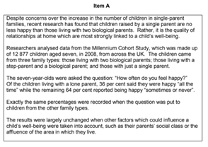  From Item A, examine one strength of the research. [2 marks] | 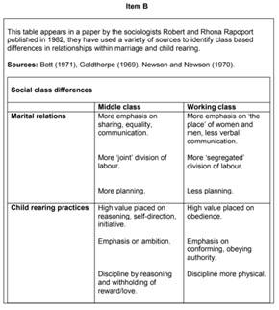  From Item B, identify and describe the research method used by the Rapoports including what you know of their perspective on the family. [4 marks]
SAM 2 | 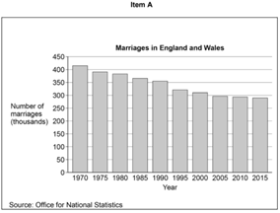  From Item A, examine one strength of using statistics to research marriage. [2 marks] | 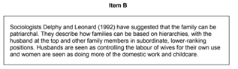  From Item B, identify and describe one way in which Delphy and Leonard believed that the family could be patriarchal, including what you know of their sociological perspective on family. [4 marks]
2019 | 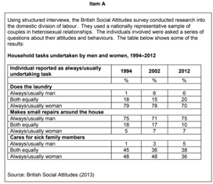  From Item A, examine one strength of the research. [2 marks] | 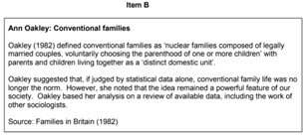  From Item B, identify and describe the research method used by Oakley, including what you know of her perspective on the family. [4 marks]
2020 | 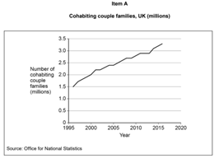From Item A, examine one strength of using statistics to research cohabiting couple families. [2 marks] | 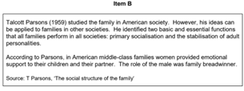  From Item B, identify and describe one way in which the family can be seen as important for society, including what you know of Parson’s perspective on the family. [4 marks]
2021 | 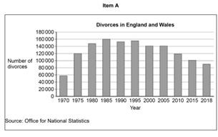  From Item A, examine one weakness of using statistics to research divorce. [2 marks] | 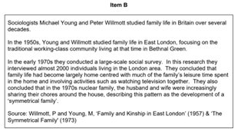  From Item B, identify and describe the research method used by Willmott and Young in the early 1970s, including what you know of their perspective on the family. [4 marks]
2022 | 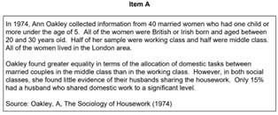  From Item A, examine one weakness of the research. [2 marks] | 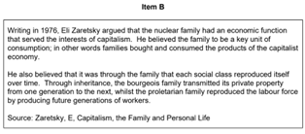  From Item B, identify and describe one way in which Zaretsky saw the family as benefiting capitalist society, including what you know of his perspective on the family. [4 marks]
2023 | 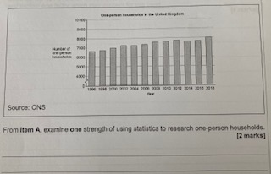  Using item A examine one strength of using statistics to research one-person households.  [2 marks] | 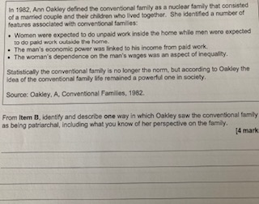  From the Item B, identify and describe one way in which Oakley saw the conventional family being patriarchal, including what you know of her perspective. [4 marks]

Family - Practice 3 Markers

Paper | Family: 3 Markers
SAM 1 | - Identify and describe one example of how patriarchy can affect the power relationship within families.  - Identify and describe one example of how patriarchy can affect the power relationship within families.
SAM 2 | - Describe how the domestic division of labour may be organised in families.  - Identify and describe one type of family diversity identified by the Rapoports.
2019 | - Describe one function of families.  - Identify and describe one criticism that Marxists make about families.
2020 | - Describe a dual career family.  - Identify and describe one factor that may have led to an increase in the number of lone parent families in Britain.
2021 | - Describe one example of patriarchy within families.  - Identify and describe one factor that may have led to an increase in family diversity in Britain.
2022 | - Describe what sociologists mean by kinship.  - Identify and describe one example of how a grandparent can contribute to family life.
2023 | - Describe one example of a commune.  - Identify and describe one consequence of divorce for family members.

My Exam Practice: Family 3 Markers
Practice 1 _____________

________________________________________________________________________________________________________________________________________________________________________________________________________________________________________________________________________________________________________________________________________________________
____________________________________________________________________________________________________________________________________________________________________________
______________________________________________________________________________________

Practice 2 _____________

________________________________________________________________________________________________________________________________________________________________________________________________________________________________________________________________________________________________________________________________________________________
____________________________________________________________________________________________________________________________________________________________________________
______________________________________________________________________________________

Practice 3 _____________

________________________________________________________________________________________________________________________________________________________________________________________________________________________________________________________________________________________________________________________________________________________
____________________________________________________________________________________________________________________________________________________________________________
______________________________________________________________________________________

Family - Practice 4 Markers
*Note: the third question in each section below is a repeat of the ‘Item B’ questions above.

Paper | Family: 4 Markers
SAM 1 | - Identify and explain one factor that may have led to an increase in the number of children raised in single-parent families referred to as a concern in Item A.  - Identify and explain one advantage of using unstructured interviews to investigate relationships between family members.  - From Item B, identify and describe the research method used by the Rapoports including what you know of their perspective on the family.  - Identify one function of the family and explain how you would investigate this function using questionnaires.
SAM 2 | - Describe the type of statistical data shown in Item A. Identify the trend shown by the data and explain one factor which may account for this trend.  - Identify and explain one advantage of using postal questionnaires to investigate the domestic division of labour within families.  - From Item B, identify and describe one way in which Delphy and Leonard believed that the family could be patriarchal, including what you know of their sociological perspective on family.  - Identify one ethical issue that you would need to consider when investigating the domestic division of labour and explain how you would deal with this issue in your investigation.
2019 | - Identify and explain one factor that may account for the traditional division of domestic labour shown in Item A.  - Identify and explain one advantage of using structured interviews to investigate conjugal role relationships.  - From Item B, identify and describe the research method used by Oakley, including what you know of her perspective on the family.  - Identify one ethical issue that you would need to consider when investigating attitudes towards arranged marriage and explain how you would deal with this issue in your investigation.
2020 | - Describe the type of statistical data shown in Item A. Identify the trend shown by the data and explain one factor which may account for this trend.  - Identify and explain one disadvantage of using postal questionnaires to investigate the domestic division attitudes towards cohabitation.  - From Item B, identify and describe one way in which the family can be seen as important for society, including what you know of Parson’s perspective on the family.  - Identify and explain one advantage of using structured interviews to research the role of parents in families.
2021 | - Describe the type of statistical data shown in Item A. Identify the trend shown by the data and explain one factor which may account for this trend.  - Identify and explain one disadvantage of using secondary data to investigate attitudes towards marriage  - From Item B, identify and describe the research method used by Willmott and Young in the early 1970s, including what you know of their perspective on the family.  - Identify one function of the family and explain how you would investigate this function using a case study.
2022 | - Identify and explain one factor that may account for the differences in the allocation of domestic tasks as shown in Item A.  - Identify and explain one advantage of using a mixed methods approach to investigate conjugal role relationships.  - From Item B, identify and describe one way in which Zaretsky saw the family as benefiting capitalist society, including what you know of his perspective on the family.  - Identify one ethical issue that you would need to consider when investigating relationships within families and explain how you would deal with this issue in your investigation.
2023 | - Identify the trend shown by the data, on one person households, and explain one factor which may account for this trend. [4 marks]  - From Item B, identify and describe one way in which Oakley saw the conventional family as being patriarchal, including what you know of her perspective. [4 marks]

My Exam Practice: Family 4 Markers

Practice 1 _____________

________________________________________________________________________________________________________________________________________________________________________________________________________________________________________________________________________________________________________________________________________________________
____________________________________________________________________________________________________________________________________________________________________________
______________________________________________________________________________________
____________________________________________________________________________________________________________________________________________________________________________
____________________________________________________________________________________________________________________________________________________________________________

Practice 2 _____________

________________________________________________________________________________________________________________________________________________________________________________________________________________________________________________________________________________________________________________________________________________________
____________________________________________________________________________________________________________________________________________________________________________
______________________________________________________________________________________

Family - Practice 12 Markers

Paper | Family: 12 Markers
SAM 1 | - Discuss how far sociologists agree that feminism has changed marriage in modern British society.  - Discuss how far sociologists agree that in Britain today social classes have different experiences of marriage and family life.
SAM 2 | - Discuss how far sociologists agree that changes in the status of women in society are the main reason for the pattern of divorce in Britain since 1945.  - Discuss how far sociologists agree that the family has lost its importance in Britain today.
2019 | - Discuss how far sociologists agree that families are the main agent of socialisation.  - Discuss how far sociologists agree that marriage is still important in Britain today.
2020 | - Discuss how far sociologists would agree that families in Britain today are symmetrical.  - Discuss how far sociologists would agree that the extended family is still important in Britain today.
2021 | - Discuss how far sociologists would agree that the traditional nuclear family is the most appropriate family type in which to raise children in Britain today.  - Discuss how far sociologists would agree that gender inequalities continue to exist within the family in Britain today.
2022 | - Discuss how far sociologists would agree that changes in the law are the main reason for the pattern of divorce in Britain since 1969.  - Discuss how far sociologists would agree the nuclear family is still considered the norm in Britain today.
2023 | - Discuss how far sociologists would agree that the main function of the family is to serve the needs of capitalism. [12 marks]  - Discuss how far sociologists would agree that gender roles are equal in families in Britain today [12 marks].

My Exam Practice: Family 12 Markers

Practice 1 _____________

________________________________________________________________________________________________________________________________________________________________________________________________________________________________________________________________________________________________________________________________________________________
____________________________________________________________________________________________________________________________________________________________________________
______________________________________________________________________________________
____________________________________________________________________________________________________________________________________________________________________________

Education - Items Exam Questions

Paper | Item C | Item D
SAM 1 | 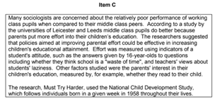  From Item C, examine one weakness in the research. [2 marks] | 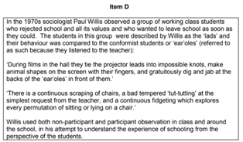  From Item D, identify and describe the research method used by Willis including what you know of his perspective on education. [4 marks]
SAM 2 | 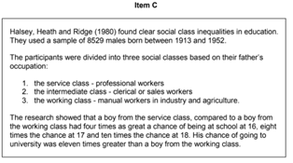  From Item C, examine one weakness in the research. [2 marks] | 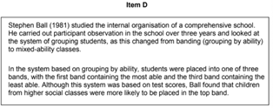  From Item D, identify and describe the research method used by Ball including what you know about his perspective on education. [4 marks]
2019 | 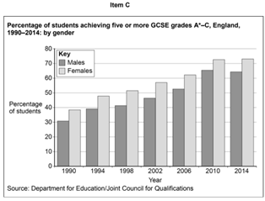  From Item C, examine one strength of the research. [2 marks] | 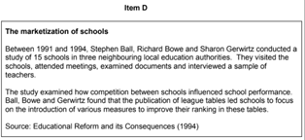  From Item D, identify and describe one impact of the marketization of schools, including what you know of Ball, Bowe and Gerwirtz’s perspective on education.[4 marks]
2020 | 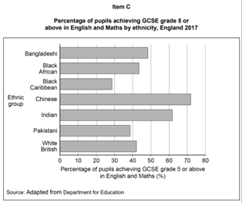  From Item C, examine one weakness of using official statistics on the educational achievement of different ethnic groups. [2 marks] | 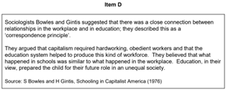  From Item D, identify and describe one example of how the correspondence principle works according to Bowles and Gintis, including what you know of their perspective on education. [4 marks]
2021 | 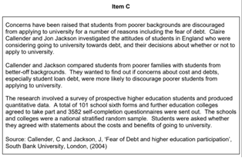  From Item C, examine one strength of the research. [2 marks] | From Item D, identify and describe one way in which Parsons saw the education system as important, including what you know of their perspective on education. [4 marks]
2022 | 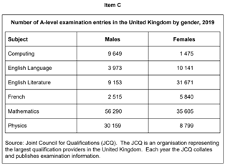  From Item C, examine one strength of using the number of entries for different A-level examinations to research gender differences in education. [2 marks] | 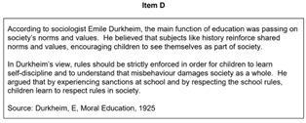  From Item D, identify and describe one way in which Durkheim believed education to be important to society, including what you know of his perspective on education. [4 marks]
20  23 | 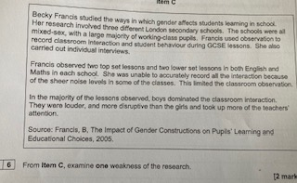  From Item C, examine one weakness of the research. [2 marks] | 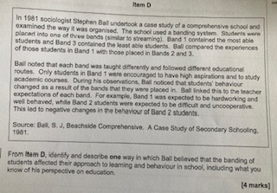  From Item D, identify and describe one way in which Ball believed that the banding of students affected their approach to learning and behaviour in school, including what you know of his perspective on education. [4 marls]

My Exam Practice: Education ‘Item C’ 2 Markers

Practice 1 _____________

________________________________________________________________________________________________________________________________________________________________________________________________________________________________________________________________________________________________________________________________________________________
______________________________________________________________________________________

Practice 2 _____________

________________________________________________________________________________________________________________________________________________________________________________________________________________________________________________________________________________________________________________________________________________________
______________________________________________________________________________________

Education - Practice 3 Markers

Paper | Education: 3 Markers  (Point Explain Example)
SAM 1 | - Describe the hidden curriculum in education  - Identify and describe one example of the cultural capital which middle class parents can use to give their children advantages at school.
SAM 2 | - Describe a home-based factor that could influence a student’s educational achievement.  - Identify and describe one example of a type of secondary school in Britain today.
2019 | - Describe one in-school factor that may influence the educational achievement of working class students.  - Identify and describe one way in which an ethnocentric curriculum might disadvantage certain groups of students.
2020 | - Describe one function of education.  - Identify and describe one type of pupil subculture that may be found in schools.
2021 | - Describe one example of the marketization of schools.  - Identify and describe one example of how labelling may affect a student’s achievement in school.
2022 | - Describe one example of cultural capital.  - Identify and describe one counter school subculture.
2023 | - Describe what is meant by the term comprehensive school. (3 marks)  - Identify and describe one example of the correspondence principle (3 marks)

My Exam Practice: Education 3 Markers
Practice 1 _____________

________________________________________________________________________________________________________________________________________________________________________________________________________________________________________________________________________________________________________________________________________________________
______________________________________________________________________________________

Practice 2 _____________

________________________________________________________________________________________________________________________________________________________________________________________________________________________________________________________________________________________________________________________________________________________
____________________________________________________________________________________________________________________________________________________________________________

Education - Practice 4 Markers
*Note: the third question in each section below is a repeat of the ‘Item D’ questions above.

Paper | Education: 4 Markers
SAM 1 | - Identify and explain one alternative factor that may have led to the relatively poor performance of working class pupils referred to as a concern in Item C.  - Identify and explain one disadvantage of using questionnaires to investigate the literacy skills of parents.  - From Item D, identify and describe the research method used by Willis including what you know of his perspective on education.  - Identify one possible label that might be attached to students who fail to conform and explain the possible impact that label might have on their school career.
SAM 2 | - Identify and explain one advantage of using a longitudinal study to investigate the relationship between social class and educational achievement as referred to in Item C.  - Identify and explain one advantage of using group interviews to investigate school subcultures.  - From Item D, identify and describe the research method used by Ball including what you know about his perspective on education.  - Identify and explain one possible effect on students of setting in schools.
2019 | - Identify and explain one out-of-school factor which might account for the differences in educational achievement shown in Item C.  - Identify and explain one disadvantage of using non-participant observation to investigate student behaviour.  - From Item D, identify and describe one impact of the marketization of schools, including what you know of Ball, Bowe and Gerwirtz’s perspective on education.  - Identify and explain one possible disadvantage of mixed ability teaching.
2020 | - Identify and explain one in-school factor which might account for the differences in educational achievement between ethnic groups shown in Item C.  - Identify and explain one advantage of using covert observation to investigate the extent of sexism in schools.  - From Item D, identify and describe one example of how the correspondence principle works according to Bowles and Gintis, including what you know of their perspective on education.  - Identify and explain one advantage of using a longitudinal study to investigate the effects of streaming students in schools.
2021 | - Identify and explain one factor, other than debt, that may discourage students from poorer backgrounds from applying to university, raised as a concern in Item C.  - Identify and explain one disadvantage of using a snowball sample to investigate attitudes of students towards higher education.  - From Item D, identify and describe one way in which Parsons saw the education system as important, including what you know of their perspective.  - Identify and explain one advantage of using unstructured interviews to investigate setting in schools.
2022 | - Identify and explain one factor, which might account for the gender differences in subject choice shown in Item C.  - Identify and explain one disadvantage of using group interviews to investigate gender-based subject choices in schools.  - From Item D, identify and describe one way in which Durkheim believed education to be important to society, including what you know of his perspective on education.  - Identify and explain one possible disadvantage of using a longitudinal study to investigate the effects of home-schooling on students.
2023 | - Identify and explain one advantage of using non-participant observation to investigate classroom interactions as shown in Item C. [4 marks]  - Identify and explain one advantage of using structured interviews to investigate working class students’ experience of school. [4 marks]  - Identify and explain one disadvantage of using snowball sampling to investigate the effects of streaming on students experience of school. [4 marks].

My Exam Practice: Education 4 Markers

Practice 1 _____________

________________________________________________________________________________________________________________________________________________________________________________________________________________________________________________________________________________________________________________________________________________________
____________________________________________________________________________________________________________________________________________________________________________
______________________________________________________________________________________
____________________________________________________________________________________________________________________________________________________________________________
____________________________________________________________________________________________________________________________________________________________________________

Practice 2 _____________

________________________________________________________________________________________________________________________________________________________________________________________________________________________________________________________________________________________________________________________________________________________
____________________________________________________________________________________________________________________________________________________________________________
______________________________________________________________________________________

Education - Practice 12 Markers

Paper | Education: 12 Markers
SAM 1 | - Discuss how far sociologists agree that the main function of the education system is to serve the needs of the economy.  - Discuss how far sociologists agree that a student’s socialisation experiences in the home are the main reason for differences in their educational achievement.
SAM 2 | - Discuss how far sociologists would agree that gender differences in educational achievement are mainly due to factors inside schools.  - Discuss how far sociologists would agree that the main function of today’s education system is to transmit the norms and values of society.
2019 | - Discuss how far sociologists would agree that a student’s social class is the main factor affecting their educational achievement.  - Discuss how far sociologists would agree that the education system prepares students for capitalist society.
2020 | - Discuss how far sociologists would agree that gender differences in educational achievement are mainly due to factors outside schools.  - Discuss how far sociologists would agree that the education system enables upward social mobility.
2021 | - Discuss how far sociologists would agree that family background is the most important factor in explaining differences in students’ educational achievement.  - Discuss how far sociologists would agree that in-school factors are the main reasons for gender-based differences in subject options and career choices.
2022 | - Discuss how far sociologists would agree that the way in which students are grouped together within the school can have a significant effect on their educational performance.  - Discuss how far sociologists would agree that the main function of the education system is to teach children how to become part of society.
2023 | - Discuss how far sociologists would agree that ethnic differences in educational achievement are mainly due to factors inside schools. [12 marks]  - Discuss how far sociologists would agree that the main function of education system is to prepare students for the work. [12 marks]

Paper 2 Crime and Deviance - Items Exam Questions

Paper | Item A | Item B
SAM 1 | 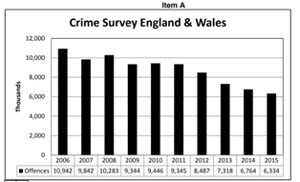  From Item A, examine one strength of research using official statistics on crime. [2 marks] | 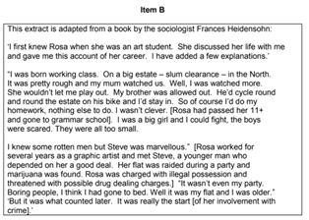  From Item B, identify and describe the method used by Frances Heidensohn including what you know of her perspective on female criminal behaviour. [4 marks]
SAM 2 | 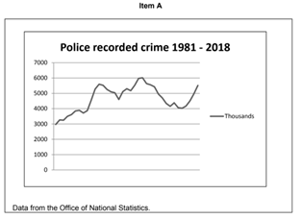  From Item A, examine one weakness of using police recorded crime statistics in research. [2 marks] | 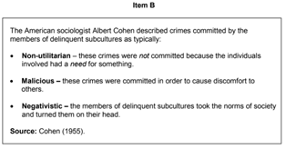  From Item B, identify and describe one example of a criminal act which Cohen believed was typical of delinquent subcultures, including what you know of his sociological perspective. [4 marks]
2019 | 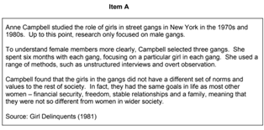  From Item C, examine one weakness in the research. [2 marks] | 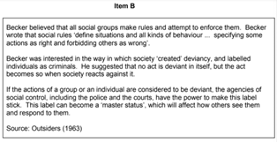  From Item B, identify and describe the one way in which Becker argued that behaviour can be labelled as deviant, including what you know of his perspective on deviance. [4 marks]
2020 | 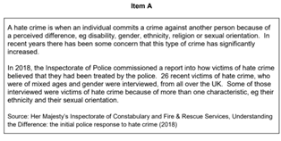  From Item A, examine one weakness of the research. [2 marks] | 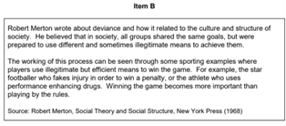  From Item B, identify and explain one factor which may explain why some people use illegitimate means of achieving their goals, including what you know of Merton’s perspective. [4 marks]
2021 | 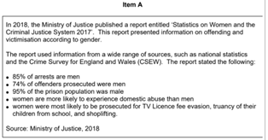  From Item A, examine one strength of the research. [2 marks] | 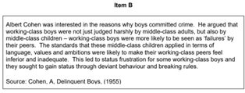  From Item B, identify and describe one reason why working-class boys develop status frustration according to Cohen, including what you know of his sociological perspective. [4 marks]
2022 | 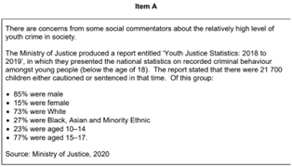  From Item A, examine one weakness of using government-reported statistics to research youth crime. [2 marks] | 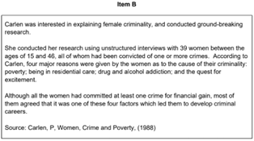  From Item B, identify and describe the research method used by Carlen, including what you know of her perspective on female criminality. [4 marks]
2023 | 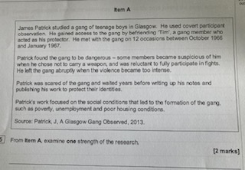  From the Item examine one strength of the research. [2 marks] | 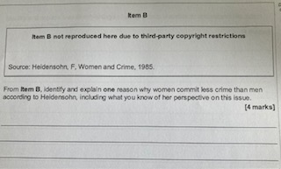From Item B, identify and explain one reason why women commit less crime than men according to Heidensohn, including what you know of her perspective on this issue. [4 marks].

My Exam Practice: Crime and Deviance ‘Item A’ 2 Markers

Practice 1 _____________

________________________________________________________________________________________________________________________________________________________________________________________________________________________________________________________________________________________________________________________________________________________
______________________________________________________________________________________

Practice 2 _____________

________________________________________________________________________________________________________________________________________________________________________________________________________________________________________________________________________________________________________________________________________________________
______________________________________________________________________________________

Practice 3 _____________

_________________________________________________________________________________________________________________________________________________________________________

Paper | Crime and Deviance: 3 Markers
SAM 1 | - Describe one example of a criminal subculture.  - Identify and describe one informal agency of social control
SAM 2 | - Describe one factor that determines whether an act is considered to be a crime.  - Identify and describe one formal agency of social control.
2019 | - Describe one example of white collar crime.  - Identify and describe one source of data on crime.
2020 | - Describe one example of a crime that has high news value.  - Identify and describe one factor that might lead to criminal behaviour.
2021 | - Describe one example of a moral panic.  - Identify and describe one example of deviant behaviour that is not criminal.
2022 | - Describe one way in which deviance can be seen to be socially constructed.  - Identify and describe one example of corporate crime.
2023 | - Describe one example of deviance. [3 marks]  - Identify and describe one way sociologists attempt to measure the dark figure of crime. [3 marks]

My Exam Practice: Crime and Deviance 3 Markers

Practice 1 _____________

________________________________________________________________________________________________________________________________________________________________________________________________________________________________________________________________________________________________________________________________________________________
______________________________________________________________________________________

Practice 2 _____________

________________________________________________________________________________________________________________________________________________________________________________________________________________________________________________________________________________________________________________________________________________________
______________________________________________________________________________________

Crime and Deviance - Practice 4 Markers
*Note: the third question in each section below is a repeat of the ‘Item B’ questions above.

Paper | Crime and Deviance: 4 Markers
SAM 1 | - Describe the type of crime survey in Item A. Identify the trend shown by the data and explain one factor which may account for this trend.  - Identify and explain one advantage of using observation to investigate policing in urban areas.  - From Item B, identify and describe the method used by Frances Heidensohn including what you know of her perspective on female criminal behaviour.  - Identify one ethical issue that you would need to consider when investigating anti-social behaviour in a community and explain how you would deal with this issue in your investigation.
SAM 2 | - Describe the type of statistical data shown in Item A. Identify the trend shown by the data and explain one factor which may account for this trend.  - Identify and explain one advantage of using victim surveys to research the level of crime in society.  - From Item B, identify and describe one example of a criminal act which Cohen believed was typical of delinquent subcultures, including what you know of his sociological perspective.  - Identify and explain one disadvantage of using self-report studies to investigate crime.
2019 | - Identify and explain one reason why the life goals of the girls did not differ from those in mainstream society, as referred to in Item A.  - Identify and explain one disadvantage of using unstructured interviews to investigate delinquent behaviour.  - From Item B, identify and describe the one way in which Becker argued that behaviour can be labelled as deviant, including what you know of his perspective on deviance.  - Identify and explain one issue for sociologists when attempting to define deviance.
2020 | - Describe the type of data shown in Item A. Identify and explain one factor that may explain an increase in police-recorded hate crime.  - Identify and explain one disadvantage of using group interviews to research the experience of prisoners.  - From Item B, identify and explain one factor which may explain why some people use illegitimate means of achieving their goals, including what you know of Merton’s perspective.  - Identify and explain why not all crime is included in official statistics.
2021 | - Identify and explain one reason for the differences in male and female criminal activity, as referred to in Item A.  - Identify and explain one ethical issue you may need to consider when investigating anti-social behaviour by teenagers.  - From Item B, identify and describe one reason why working-class boys develop status frustration according to Cohen, including what you know of his sociological perspective.  - Identify and explain one advantage of using official crime statistics to investigate inner-city crime.
2022 | - Identify and explain one factor which may account for the relatively high level of crime that is committed by young people, according to Item A.  - Identify and explain one disadvantage of using overt observation to study anti-social behaviour amongst young people.  - From Item B, identify and describe the research method used by Carlen, including what you know of her perspective on female criminality.  - Identify one disadvantage of using a qualitative method to investigate criminal behaviour and explain how you would deal with this in your investigation.
2023 | - Identify and explain one factor which may have led to the boys joining the gang, according to Item A. [4 marks]  - Identify and explain one disadvantage of using a case study to investigate a teenage gang [4 marks]  - Identify and explain one disadvantage of using official statistics to understand the extent of crime committed by women [4 marks]

My Exam Practice: Crime and Deviance 4 Markers

Practice 1 _____________

________________________________________________________________________________________________________________________________________________________________________________________________________________________________________________________________________________________________________________________________________________________
____________________________________________________________________________________________________________________________________________________________________________
______________________________________________________________________________________
____________________________________________________________________________________________________________________________________________________________________________
____________________________________________________________________________________________________________________________________________________________________________

Practice 2 _____________

________________________________________________________________________________________________________________________________________________________________________________________________________________________________________________________________________________________________________________________________________________________
____________________________________________________________________________________________________________________________________________________________________________
______________________________________________________________________________________

Crime and Deviance - Practice 12 Markers

Paper | Crime and Deviance: 12 Markers
SAM 1 | - Discuss how far sociologists agree that official statistics of crime do not accurately reflect the true level of middle class criminal behaviour.  - Discuss how far sociologists agree that the level of youth crime reflects how well parents control their children.
SAM 2 | - Discuss how far sociologists agree that crimes are more likely to be committed by members of the working class rather than members of the middle class.  - Discuss how far sociologists would agree that the mass media can affect people’s awareness of how much crime there is in society.
2019 | - Discuss how far sociologists would agree that institutional racism remains an issue in the criminal justice system.  - Discuss how far sociologists would agree that inadequate socialisation is the main cause of criminal and deviant behaviour.
2020 | - Discuss how far sociologists would agree that women are less likely to commit crime than men.  - Discuss how far sociologists would agree that deviant behaviour may have an important function in society.
2021 | - Discuss how far sociologists would agree that members of some ethnic groups who are convicted of crimes are more likely to receive a prison sentence.  - Discuss how far sociologists would agree that social inequality is the main cause of criminal behaviour.
2022 | - Discuss how far sociologists would agree that prison is an effective form of social control.  - Discuss how far sociologists would agree that youth crime can be explained by negative labelling.
2023 | - Discuss how far sociologists would agree that informal social control is an effective way of controlling deviant behaviour. [12 marks]  - Discuss how far sociologists would agree that people commit crime because of a lack of opportunities within society [12 marks]

My Exam Practice: Crime and Deviance 12 Markers

Practice 1 _____________

________________________________________________________________________________________________________________________________________________________________________________________________________________________________________________________________________________________________________________________________________________________
____________________________________________________________________________________________________________________________________________________________________________
______________________________________________________________________________________
____________________________________________________________________________________________________________________________________________________________________________
______________________________________________________________________________________
______________________________________________________________________________________
____________________________________________________________________________________________________________________________________________________________________________
______________________________________________________________________________________
______________________________________________________________________________________
____________________________________________________________________________________________________________________________________________________________________________
______________________________________________________________________________________
______________________________________________________________________________________
____________________________________________________________________________________________________________________________________________________________________________
______________________________________________________________________________________
______________________________________________________________________________________
____________________________________________________________________________________________________________________________________________________________________________
______________________________________________________________________________________
______________________________________________________________________________________
____________________________________________________________________________________________________________________________________________________________________________
______________________________________________________________________________________
______________________________________________________________________________________
____________________________________________________________________________________________________________________________________________________________________________
______________________________________________________________________________________

Social Stratification - Items Exam Questions

Paper | Item C | Item D
SAM 1 | 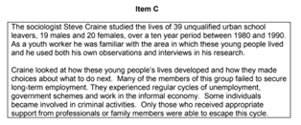  From Item C, examine one strength of the research. [2 marks] | 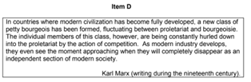  From Item D, identify and describe one group that Marx believed had failed to benefit from the development of industry, including what you know of his perspective on these events. [4 marks]
SAM 2 | 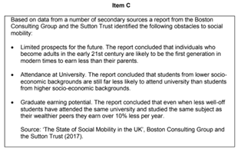  From Item C, examine one weakness of the research. [2 marks] | 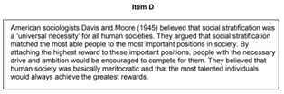  From Item D, identify and describe one group that would benefit from social stratification, including what you know of Davies and Moore’s sociological perspective.[4 marks]
2019 | 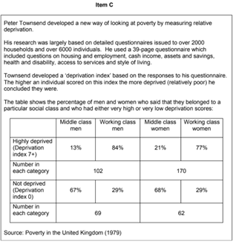  From Item C, examine one weakness of the research. [2 marks] | 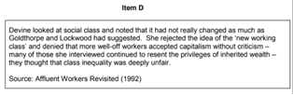  From Item D, identify and describe the one way Devine suggests that class attitudes have not changed significantly, including what you know of her perspective on this issue. [4 marks]
2020 | 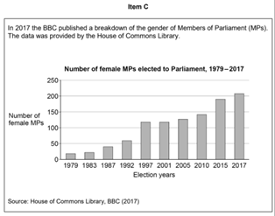  From Item C, examine one strength of the research. [2 marks] | 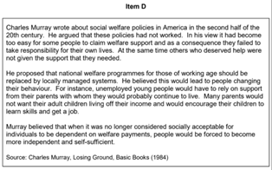  From Item D, identify and explain one reason why Murray believed that welfare reform was needed, including what you know of his perspective on this issue. [4 marks]
2021 | 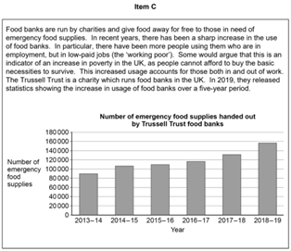  From Item C, examine one weakness of using non-official statistics to investigate poverty. [2 marks] | 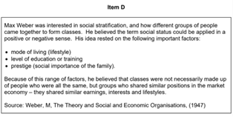  From Item D, identify and describe one factor that Weber believed to be important when deciding on an individual’s social status, including what you know of his perspective on this issue. [4 marks]
2022 | 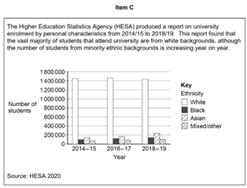  From Item C, examine one strength of the research. [2 marks] | 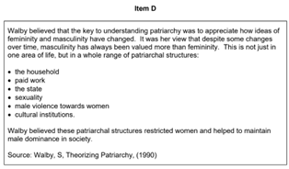  From Item D, identify and describe one patriarchal structure as identified by Walby, including what you know of her perspective of gender inequality. [4 marks]
2023 | 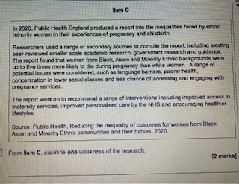  From Item examine one weakness of the research. [2 marks] | 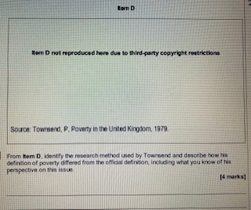  From Item D, identify the research method used by Townsend and describe how his definition of poverty differed from the official definition, including what you know of his perspective on this issue. [4 marks]

Social Stratification - Practice 3 Markers

Paper | Social Stratification: 3 Markers
SAM 1 | - Describe one example of ascribed status.  - Identify and describe one example of how the traditional role of women in society may make them more likely to experience poverty.
SAM 2 | - Describe one example of achieved status.  - Identify and describe one example of social mobility.
2019 | - Describe one example of a barrier that may limit or prevent social mobility.  - Identify and describe one form of authority according to Weber.
2020 | - Describe one way society may exploit women.  - Identify and describe one type of social inequality.
2021 | - Describe one type of poverty.  - Identify and describe one factor that might affect an individual’s life chances.
2021 | - Describe one example of stratification.  - Identify and describe one example of a social group who are more likely to experience poverty.
2022 | - Describe one example of social stratification. [ 3 marks]  - Identify and describe one example of a social group who are more likely to experience poverty. [3 marks]
2023 | - Identify and describe one example of age discrimination [3 marks]  - Describe one feature of a meritocracy. [3 marks]

My Exam Practice: Social Stratification 3 Markers
Practice 1 _____________

________________________________________________________________________________________________________________________________________________________________________________________________________________________________________________________________________________________________________________________________________________________
____________________________________________________________________________________________________________________________________________________________________________
______________________________________________________________________________________

Social Stratification - Practice 4 Markers
*Note: the third question in each section below is a repeat of the ‘Item D’ questions above.

Paper | Social Stratification: 4 Markers
SAM 1 | - Identify and explain one factor which might limit a young person’s opportunities to find secure long-term employment as experienced by many of the young people referred to in Item C  - Identify and explain one disadvantage of using structured interviews to research young people’s experience of unemployment.  - From Item D, identify and describe one group that Marx believed had failed to benefit from the development of industry, including what you know of his perspective on these events.  - Identify and explain one feature of British society which led the sociologist Charles Murray to conclude that there was a growing underclass in Britain.
SAM 2 | - Identify and explain one factor which might account for less well-off students earning less than their wealthier peers as referred to in Item C.  - Identify and explain one disadvantage of using official statistics to measure social mobility.  - From Item D, identify and describe one group that would benefit from social stratification, including what you know of Davies and Moore’s sociological perspective.  - Identify one reason why individuals might experience poverty and explain how you would investigate poverty using interviews.
2019 | - Identify and explain one factor that may lead to a person experiencing poverty as referred to in Item C.  - Identify and explain one disadvantage of using relative measurements of poverty.  - From Item D, identify and describe the one way Devine suggests that class attitudes have not changed significantly, including what you know of her perspective on this issue. [4 marks]  - Identify and explain one way in which age continues to divide British society.
2020 | - Identify and explain one factor that may have led to an increase in the number of female MPs being elected, as shown in Item C.  - Identify and explain one way in which sociologists might determine an individual's social class.  - From Item D, identify and explain one reason why Murray believed that welfare reform was needed, including what you know of his perspective on this issue. [4 marks]  - Identify and explain one factor that can lead to an individual becoming dependent on the welfare system.
2021 | - Identify and explain one factor which may account for the increased use of food banks as referred to in Item C.  - Identify and explain one advantage of using questionnaires to investigate an individual’s experience of poverty.  - From Item D, identify and describe one factor that Weber believed to be important when deciding on an individual’s social status, including what you know of his perspective on this issue.  - Identify and explain one factor affecting power relationships.
2022 | - Identify and explain one factor which may account for the relatively low numbers of students from some ethnic minority backgrounds attending university, as referred to in Item C.  - Identify and explain one advantage of using ethnography as a research method to investigate life chances..  - From Item D, identify and describe one patriarchal structure as identified by Walby, including what you know of her perspective of gender inequality.  - Identify and explain one way in which social class at birth can influences an individual’s future life chances.
2023 | - Describe the type of research in Item C. Identify and explain one factor considered by the report as a possible explanation for the inequality experienced by some women from Black, Asian and Minority Ethnic backgrounds. [4 marks]  - Identify and explain one advantage of using previously published research to investigate gender inequality in accessing health care. [4 marks]  - From Item D, identify the research method used by Townsend and describe how his definition of poverty differed from the official definition, including what you know of his perspective on this issue. [4 marks]  - Identify and explain one reason why some researchers believe that relative deprivation is an idea with significant problems. [4 marks]

My Exam Practice: Social Stratification 4 Markers
Practice 1 _____________

________________________________________________________________________________________________________________________________________________________________________________________________________________________________________________________________________________________________________________________________________________________
____________________________________________________________________________________________________________________________________________________________________________
______________________________________________________________________________________

Practice 2 _____________

________________________________________________________________________________________________________________________________________________________________________________________________________________________________________________________________________________________________________________________________________________________
____________________________________________________________________________________________________________________________________________________________________________
______________________________________________________________________________________

Social Stratification - Practice 12 Markers

Paper | Social Stratification: 12 Markers
SAM 1 | - Discuss how far sociologists agree that social class rather than gender or ethnicity is the most important division in British society.  - Discuss how far sociologists agree that a breakdown of the traditional family is one of the most important reasons that child poverty exists in modern British society.
SAM 2 | - Discuss how far sociologists agree that official statistics underestimate the actual level of poverty in society.  - Discuss how far sociologists agree that Britain is a meritocratic society in which everyone has equal opportunities to succeed.
2019 | - Discuss how far sociologists would agree that a glass ceiling for women still exists in British society.  - Discuss how far sociologists would agree that the welfare state has helped to create a culture of dependency amongst some groups in Britain.
2020 | - Discuss how far sociologists would agree that society will always be unequal.  - Discuss how far sociologists would agree that poverty remains an issue in Britain today.
2021 | - Discuss how far sociologists would agree that social class is the most important factor affecting an individual’s life chances.  - Discuss how far sociologists would agree that capitalism exploits certain groups in society.
2022 | - Discuss how far sociologists would agree that Britain today is a meritocracy.  - Discuss how far sociologists would agree that the welfare state has been successful in reducing poverty.
2023 | - Discuss how far sociologists would agree that the welfare state creates an underclass. [12 marks]  - Discuss how far sociologists would agree that patriarchy continues to exist in modern British society. [12 marks]

My Exam Practice: Social Stratification 12 Markers

Practice 1 _____________

________________________________________________________________________________________________________________________________________________________________________________________________________________________________________________________________________________________________________________________________________________________
____________________________________________________________________________________________________________________________________________________________________________
______________________________________________________________________________________
____________________________________________________________________________________________________________________________________________________________________________

